**Installing terraform on windows and configuring:**

* Download Terraform from chrome for windows version- <https://developer.hashicorp.com/terraform/install>
* Its always good to extract and keep the file in c drive system32 ----- Go to downloads—right click – extract all – browse – c drive – windows—system32 – give ok
* Now we have to set the environment path- In windows go to Edit system environment variable ---- Environment variables --- Path (Down)----edit ---new---(V have to give path of our terraform) --- Go to terraform in system32—right click and click on properties – copy the location and paste it in the new location and give\terraform ---- ok—ok---ok.

**Download VS Code, and Hashicorp Terraform autocomplete extension**

* Instal VS Code for windows 64bit – open—Extensions in side – search for Hashicrop Terraform and Terraform Autocomplete and install it.

**Download and install AWS CLI on windows**

* Download Aws cli for windows from chrome and install it.

**Create IAM user in AWS attaching Admin access , Access key and S.Access key**

* In AWS console--- create IAM user and also create keys and download the csv file.

**Configure IAM user --- AWS Configure**

* In vs code check for terraform -v
* aws configure --- give ac key, sac key, region, format :json

**Creating directory and create EC2 instance in AWS using Terraform**

* Go to c drive and create a new folder Terraform.
* Now in VS code create on file –new folder --- browse terraform from c drive and give ok.
* Now under Terraform in VS Code create a new file as **main.tf**
* **Screenshot for creating EC2 instance using terraform**
* provider "aws" {
* region = "us-east-1"
* }
* resource "aws_instance" "Demo" {
* ami           = "ami-0c7217cdde317cfec"
* instance_type = "t2.micro"
* key_name = "Demo_keypair"
* tags = {
* Name = "Terraform_demo"
* }
* }
* **terraform init**
* **terraform validate**
* **terraform plan**
* **terraform apply**

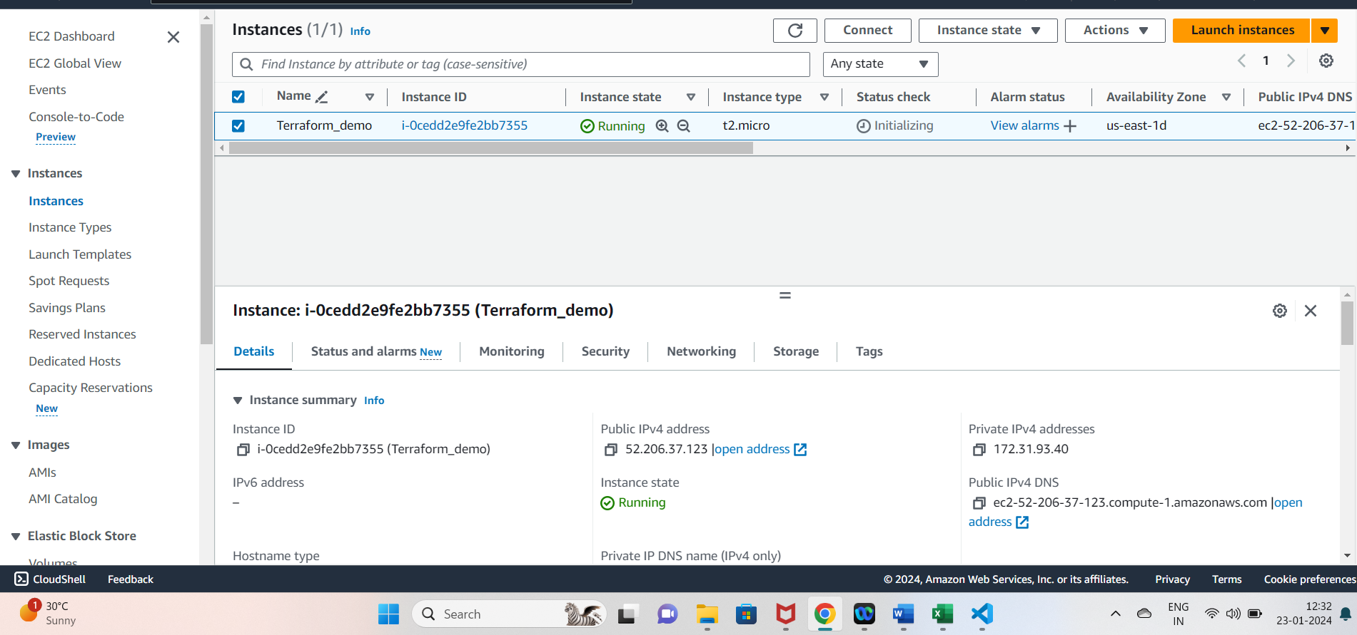

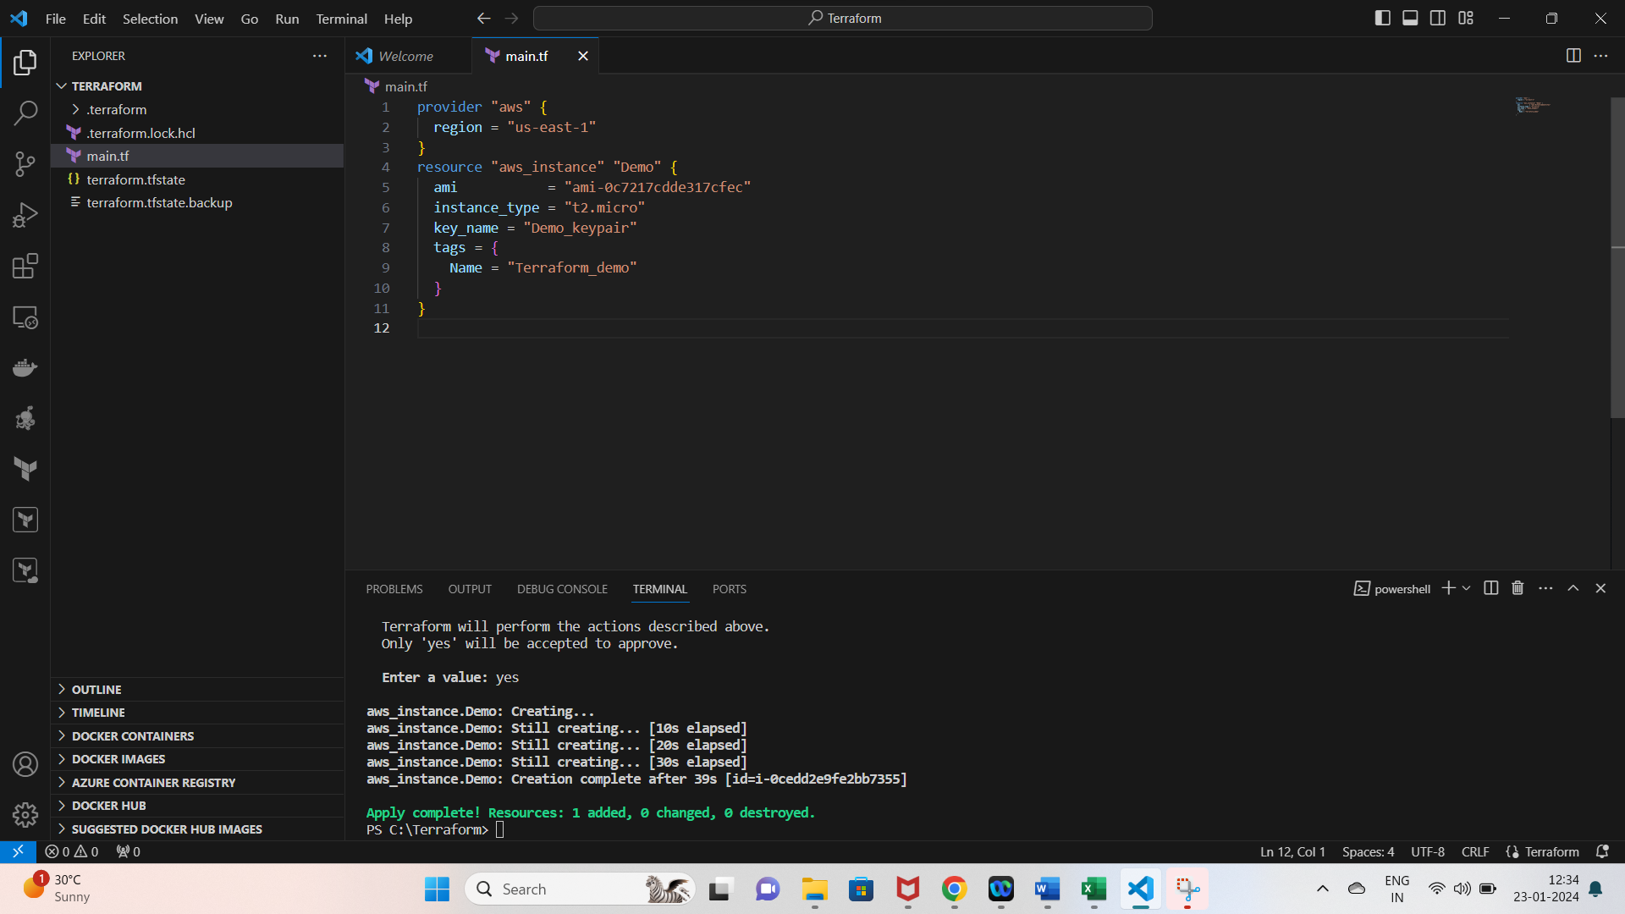

**Extra :**

1. **To create VPC:**

Whenever we create VPC we should pass CIDR block and add tags( tags are what we **see on the console)**

1. **To create a public subnet :**

Create resource

To create subnet we should vpc id

Cidr block

Availability zone

1. **To create private subnet**
2. **To create internet gateway:**

Internet gateway is necessary to have internet connection to public subnet.

1. **Route table for public subnet**

We have to define the route and then attach it to the Internet gateway.

1. **Route table association public subnet**

This is done to map this route table to the public subnet that is created.

1 : Create a VPC

resource "aws_vpc" "myvpc"{

    cidr_block = "10.0.0.0/16"

    tags = {

        Name = "MyVPC"

    }

}

 2: Create a public subnet

resource "aws_subnet" "PublicSubnet"{

    vpc_id = aws_vpc.myvpc.id

    availability_zone = "us-east-1a"

    cidr_block = "10.0.1.0/24"

}

 3 : create a private subnet

resource "aws_subnet" "PrivSubnet"{

    vpc_id = aws_vpc.myvpc.id

    cidr_block = "10.0.2.0/24"

    map_public_ip_on_launch = true

}

 4 : create IGW

resource "aws_internet_gateway" "myIgw"{

    vpc_id = aws_vpc.myvpc.id

}

 5 : route Tables for public subnet

resource "aws_route_table" "PublicRT"{

    vpc_id = aws_vpc.myvpc.id

    route {

        cidr_block = "0.0.0.0/0"

        gateway_id = aws_internet_gateway.myIgw.id

    }

}

 6 : route table association public subnet

resource "aws_route_table_association" "PublicRTAssociation"{

    subnet_id = aws_subnet.PublicSubnet.id

    route_table_id = aws_route_table.PublicRT.id

}

**terraform init**

**terraform validate**

**terraform plan**

**terraform apply**

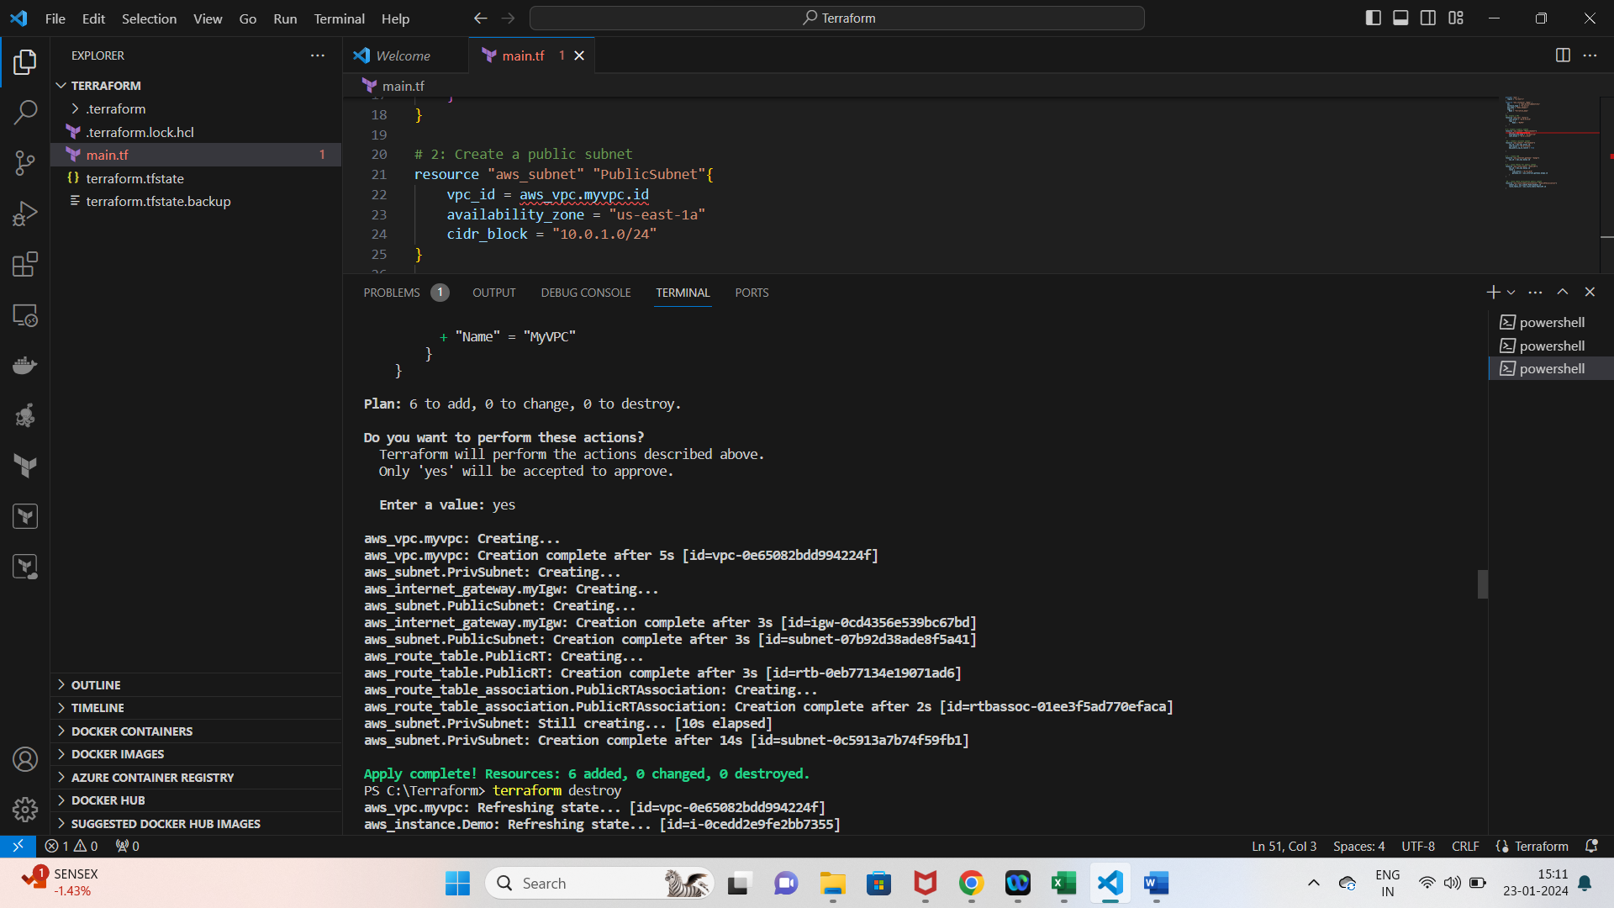

**terraform destroy**

